**4. CONTROL STRUCTURES**

**FORM DESIGN**

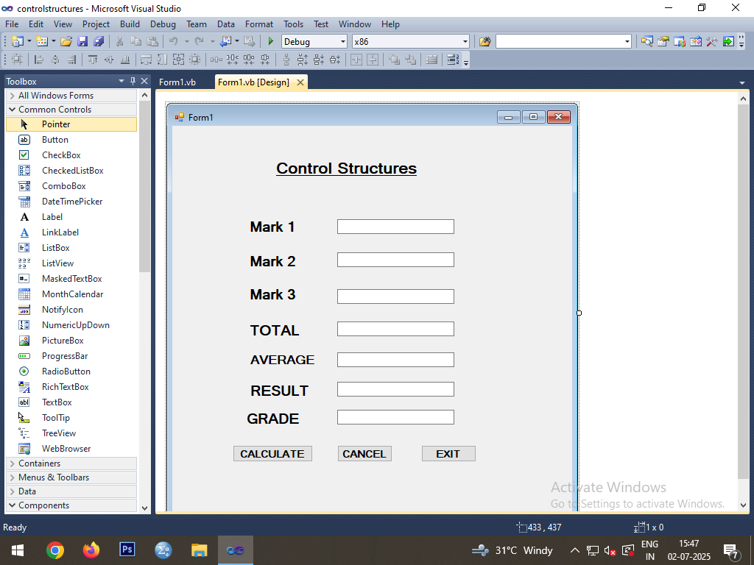

**CODING**

Public Class Form1

Dim grade As String

Private Sub Button1_Click(ByVal sender As Object, ByVal e As System.EventArgs) Handles Button1.Click

TextBox4.Text = Val(TextBox1.Text) + Val(TextBox2.Text) + Val(TextBox3.Text)

If TextBox1.Text >= 40 And TextBox2.Text >= 40 And TextBox3.Text >= 40 Then

TextBox5.Text = "Pass"

Else

TextBox5.Text = "Fail"

End If

TextBox7.Text = TextBox4.Text / 3

If TextBox7.Text >= 90 Then

grade = "O"

ElseIf TextBox7.Text >= 80 Then

grade = "A"

ElseIf TextBox7.Text >= 70 Then

grade = "B"

ElseIf TextBox7.Text >= 60 Then

grade = "C"

ElseIf TextBox7.Text >= 50 Then

grade = "D"

ElseIf TextBox7.Text >= 40 Then

grade = "E"

Else

grade = "FAIL"

End If

TextBox6.Text = grade

End Sub

Private Sub Button2_Click(ByVal sender As System.Object, ByVal e As System.EventArgs) Handles Button2.Click

TextBox1.Text = " "

TextBox2.Text = " "

TextBox3.Text = " "

TextBox4.Text = " "

TextBox5.Text = " "

TextBox6.Text = " "

TextBox7.Text = " "

End Sub

Private Sub Button3_Click(ByVal sender As Object, ByVal e As System.EventArgs) Handles Button3.Click

End

End Sub

End Class

**OUTPUT**

